**PIEZO BUZZER**

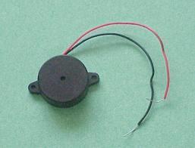

The piezo buzzer produces sound based on reverse of the piezoelectric effect. The generation of pressure variation or strain by the application of electric potential across a piezoelectric material is the underlying principle. These buzzers can be used to alert a user of an event corresponding to a switching action, counter signal or sensor input. They are also used in alarm circuits.

  The buzzer produces a same noisy sound irrespective of the voltage variation applied to it. It consists of piezo crystals between two conductors. When a potential is applied across these crystals, they push on one conductor and pull on the other. This, push and pull action, results in a sound wave. Most buzzers produce sound in the range of 2 to 4 kHz.

The red lead is connected to the input and the black lead to the ground.

**Pin Diagram:**

